Date:12.02.2022

**Third Year B. Tech., Sem VI 2021-22**

**Advanced Database System Lab**

**Assignment submission**

**PRN No: 2019BTECS00064**

**Full name: Kunal Santosh Kadam**

**Batch: T2**

**Assignment: 4**

**Title of assignment: Web-based Student Management System**

Design an implement a web-enabled (portal) student MIS (Management

Information System) for university schema attached in separate file.

**Technology stack: Go Language / MySQL or Oracle/ Bootstrap v5.0, look and feel UI template**

Requirement Specifications :

1. User management at different levels
2. Entry form for each entity
3. Generic report generation : Should able to display/list any data.

Ans:

Starting of MySQL and Apache Modules on XAMPP Control Panel

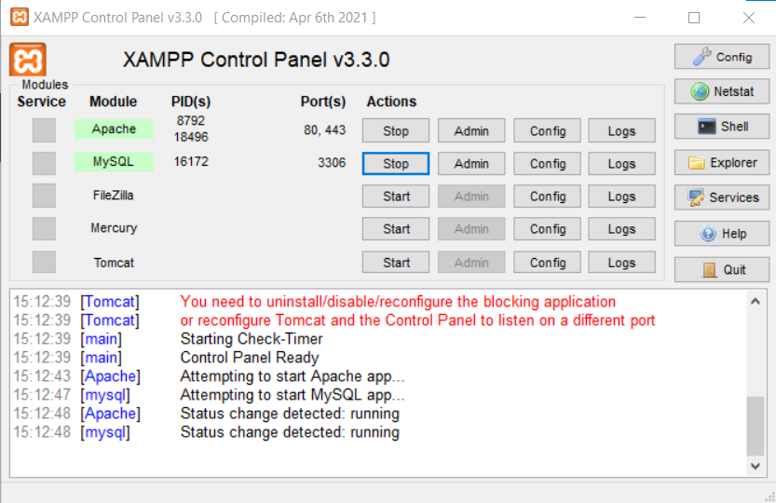

Database Created

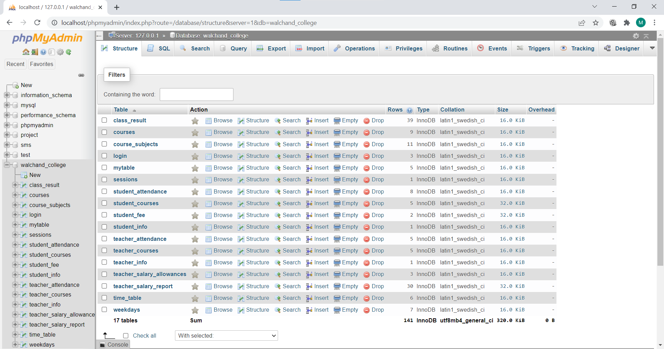

Coding

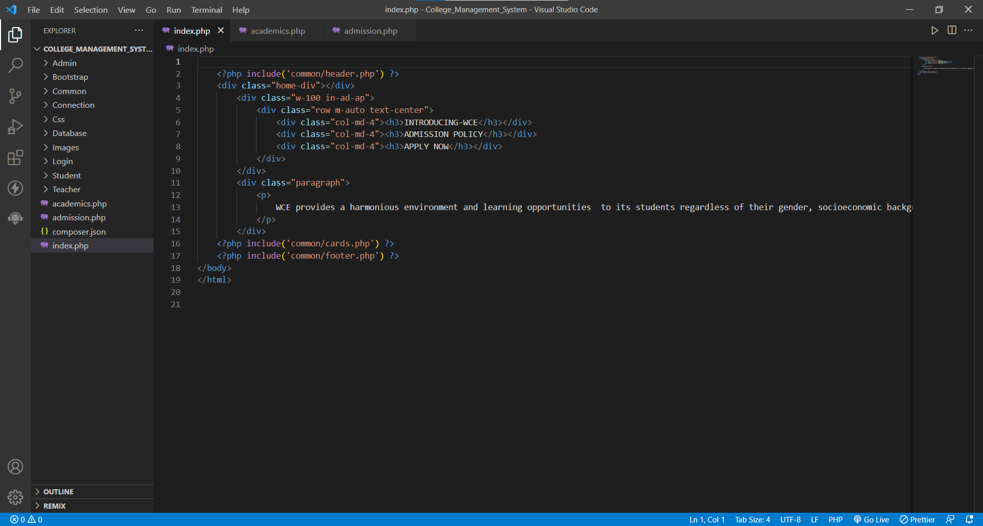

Homepage

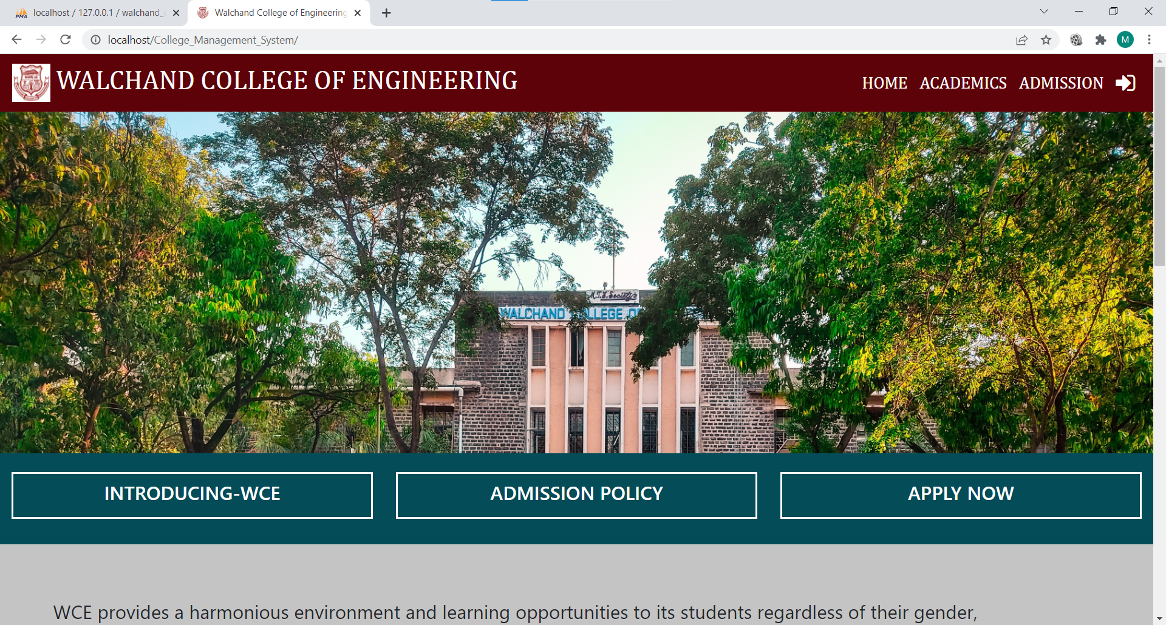



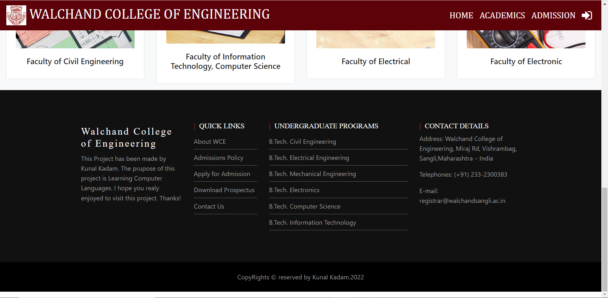

Academics Pages

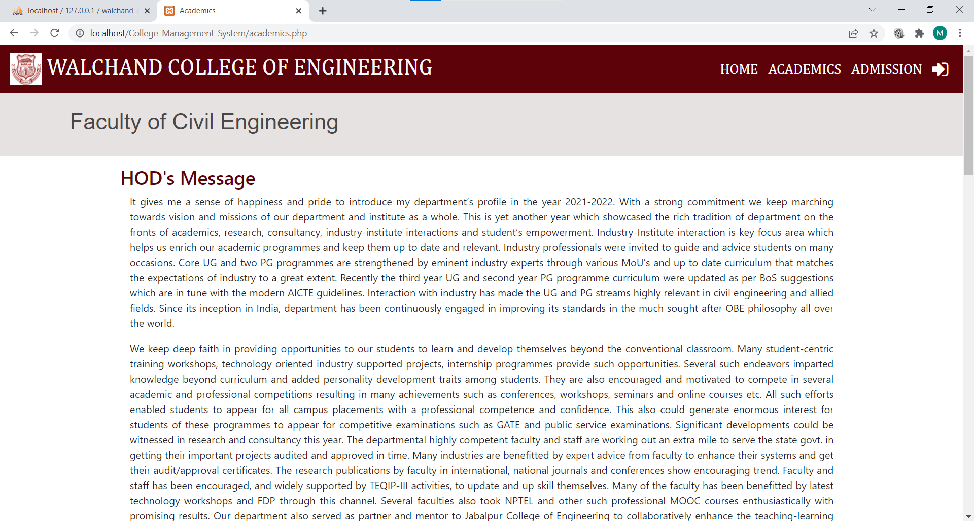

Admission Page

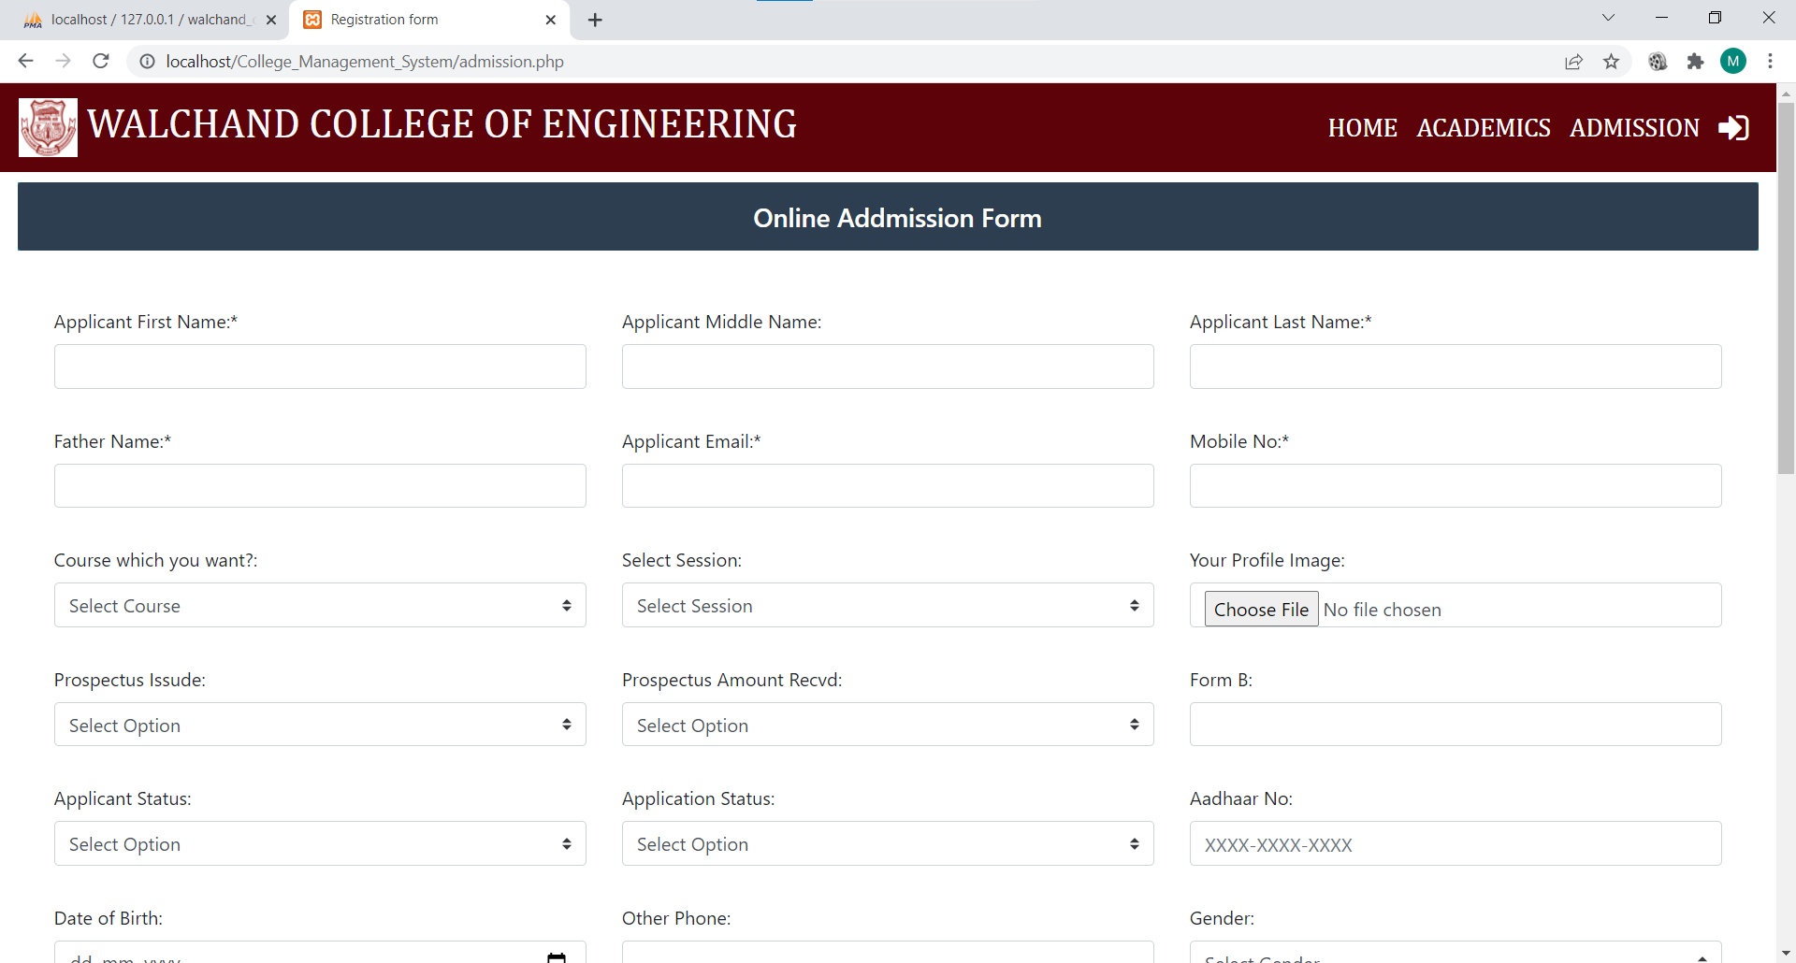

Login Page

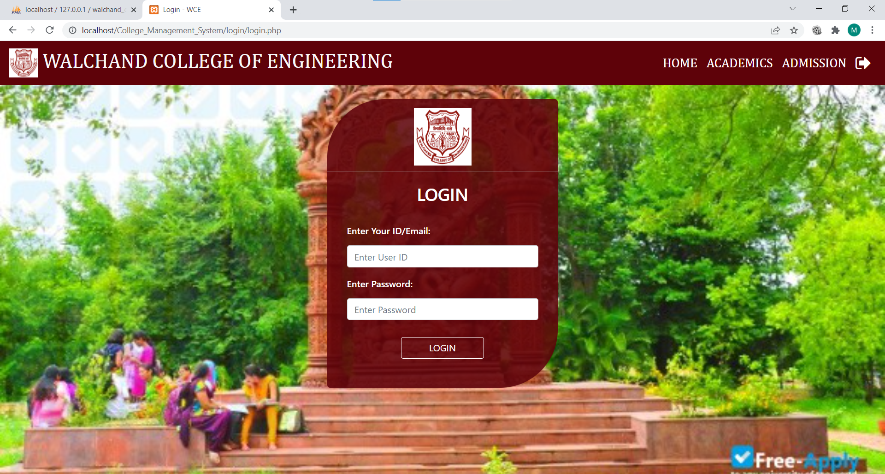

Admin Page

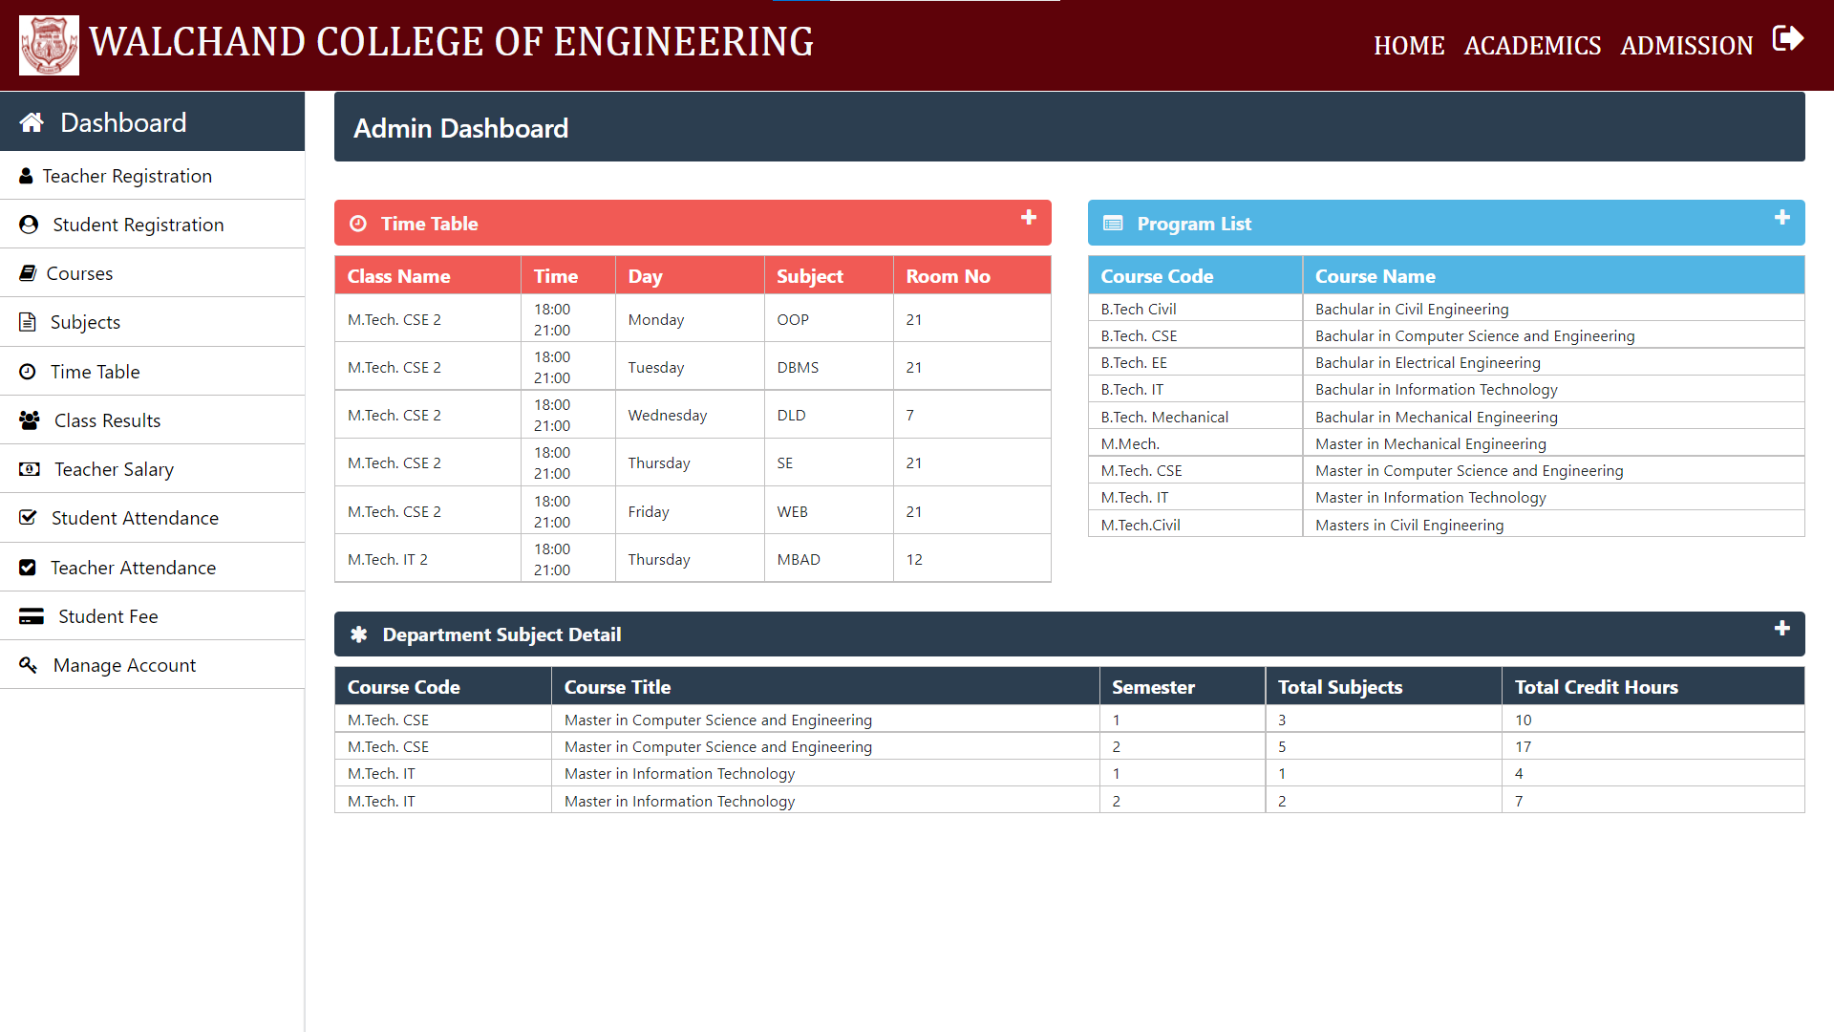

Admin Course Management Page

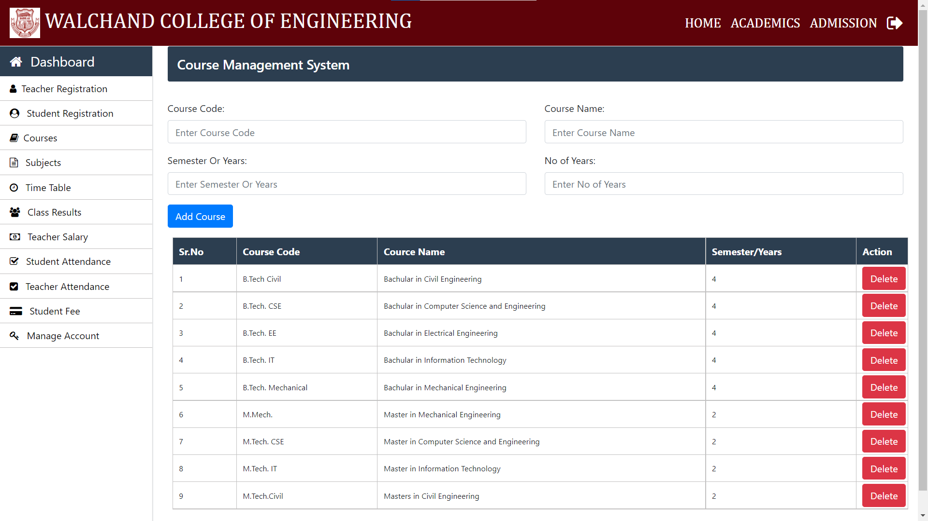

Admin Teacher Registration

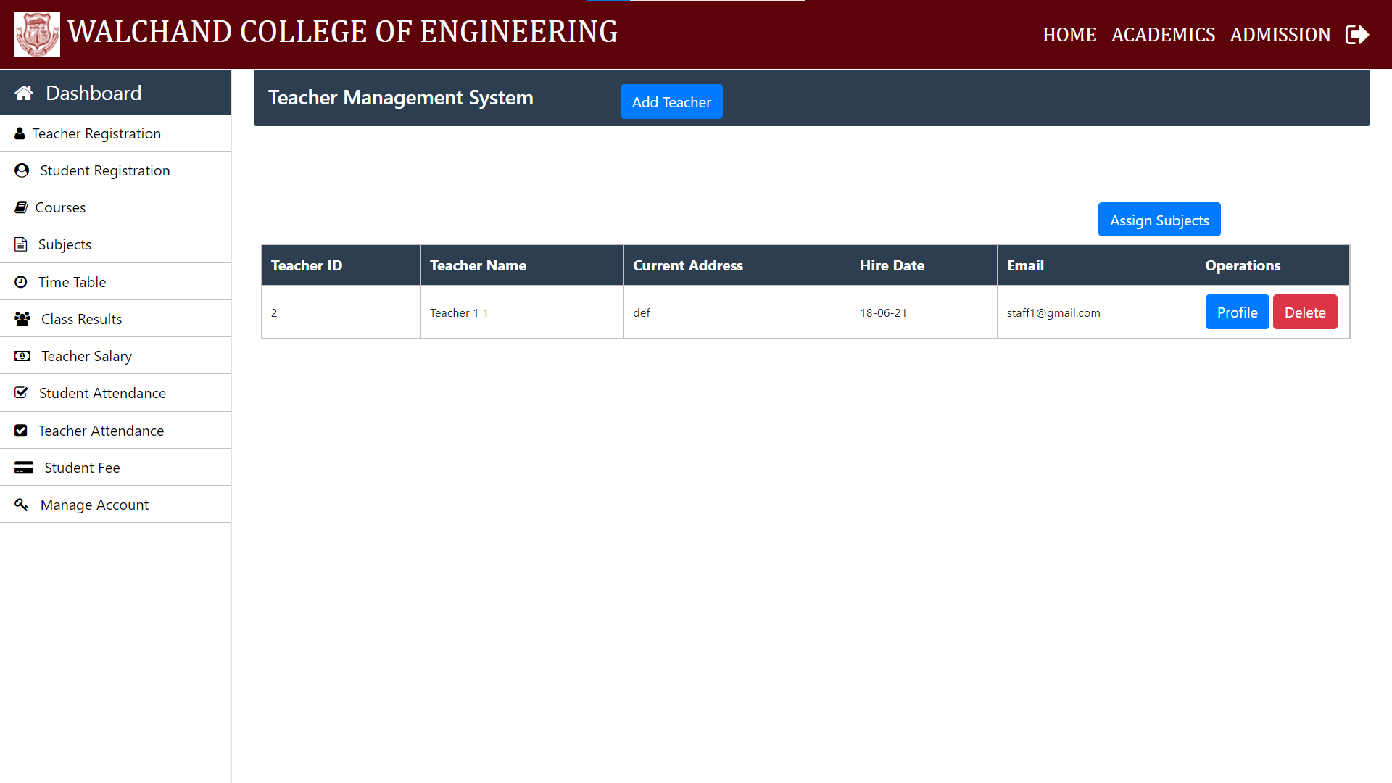

Admin: Student Registration

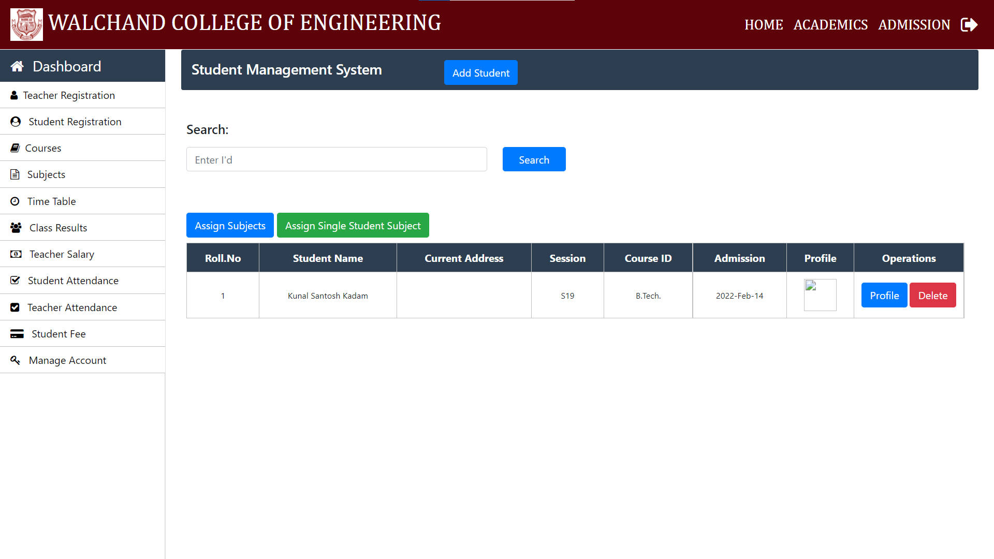

Admin: Subject Management System

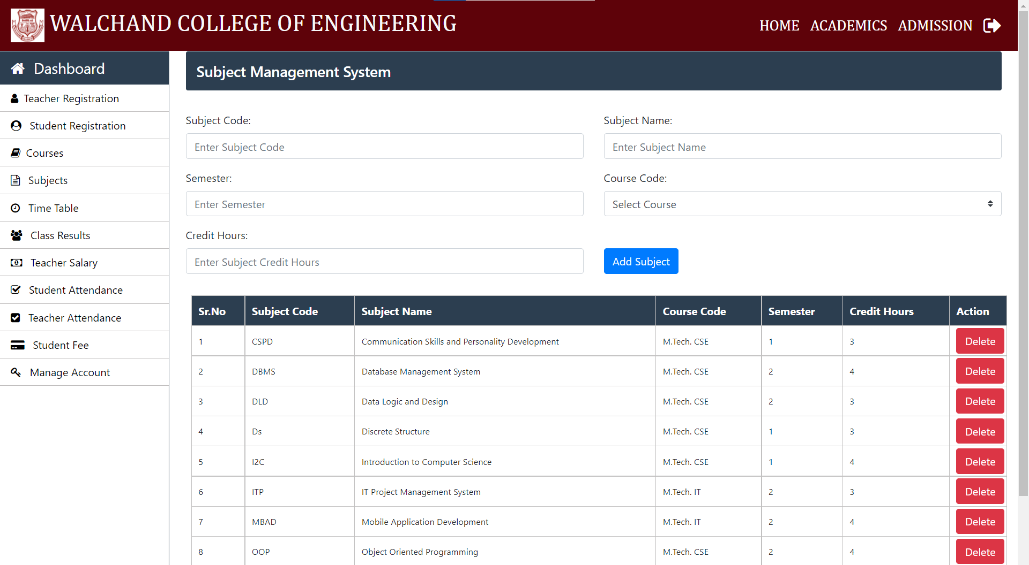

Admin: Time Table Management System

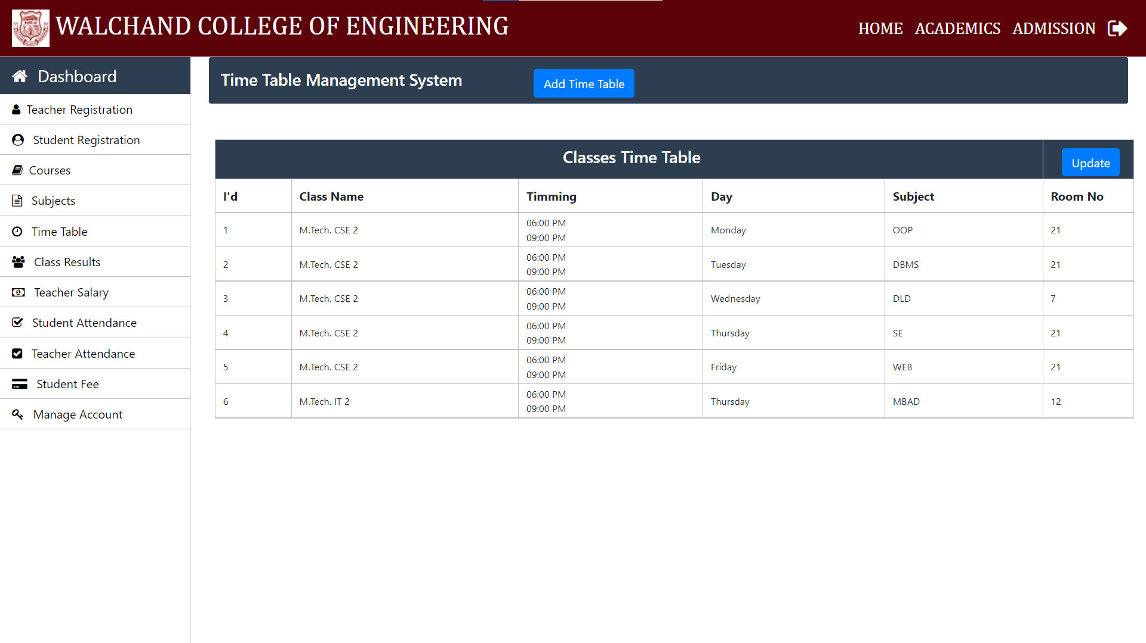

Admin: Teacher Salary Management System

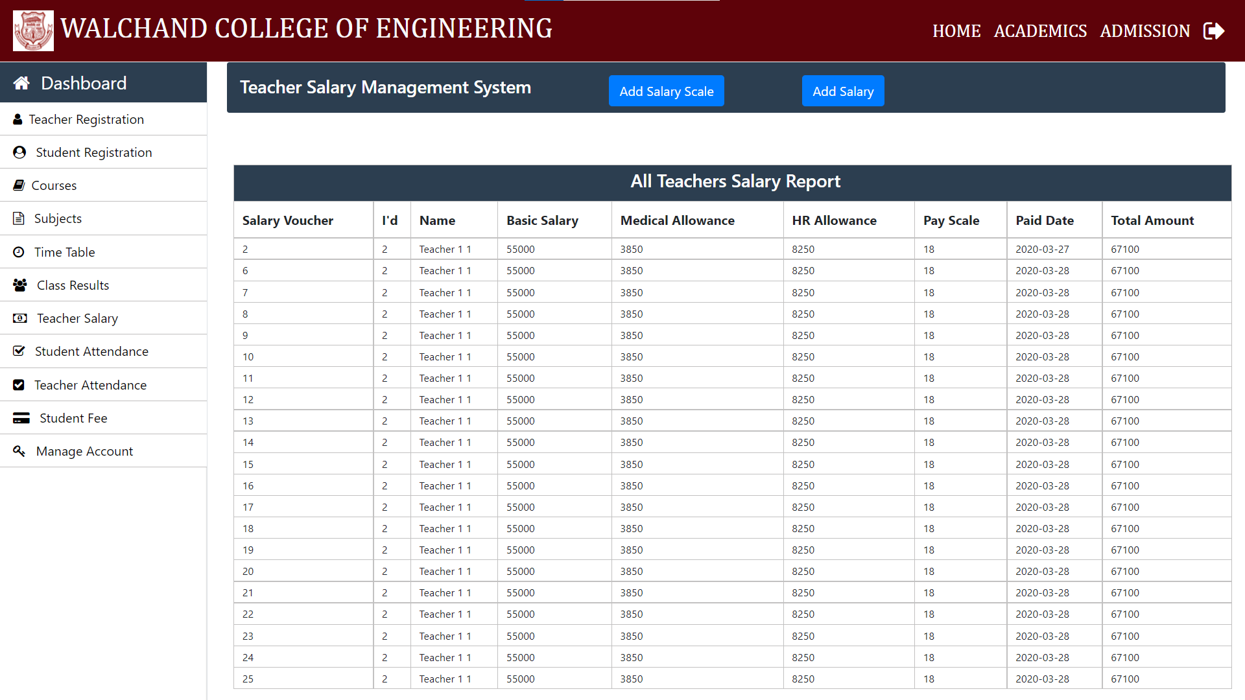

Teacher Dashboard Page

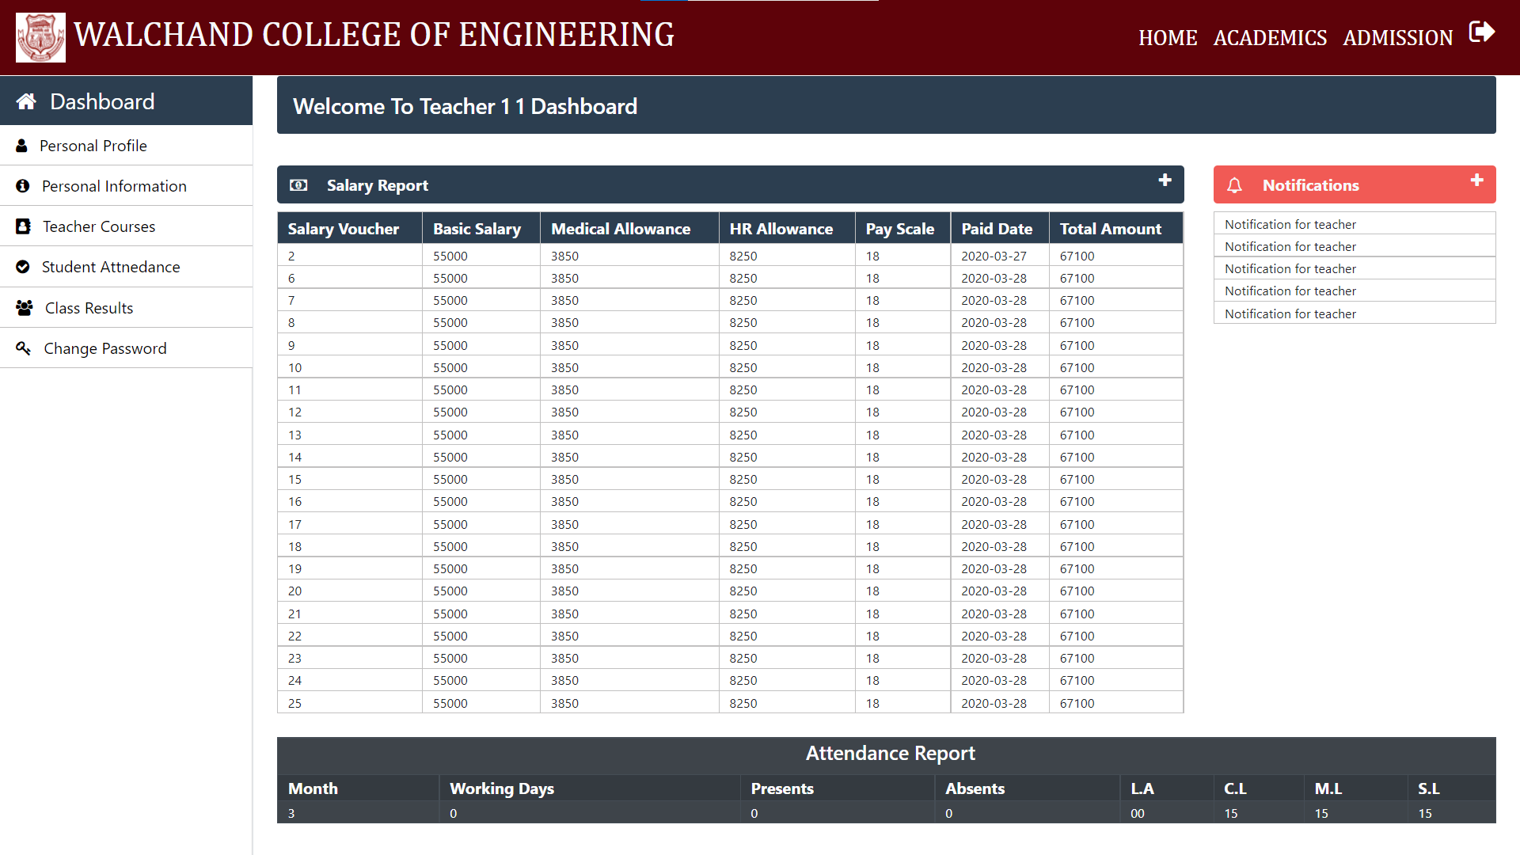

Teacher Personal Page

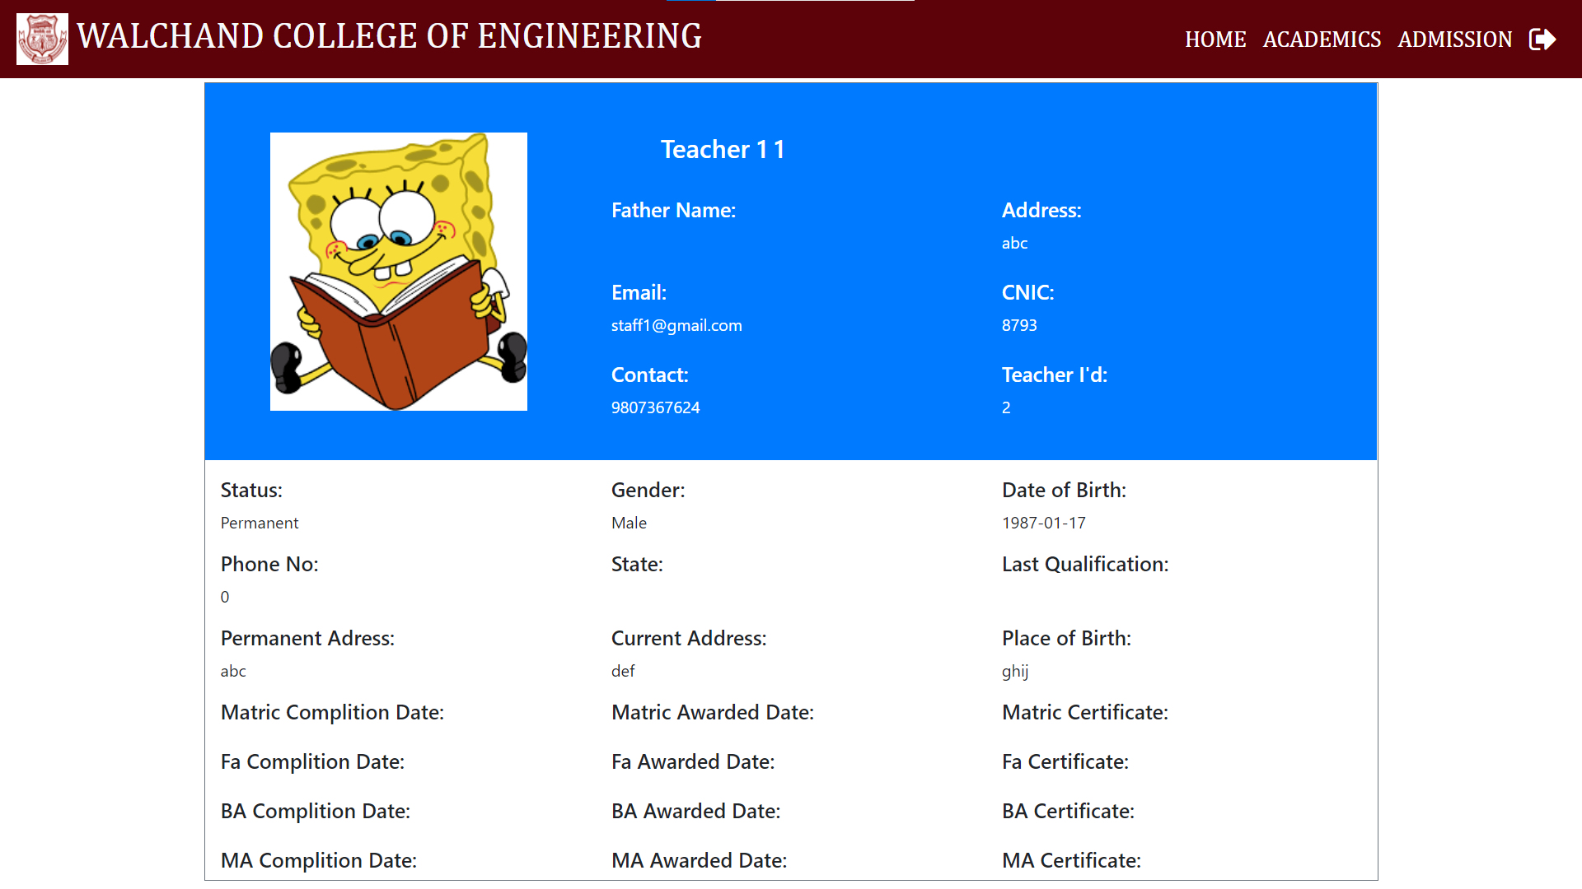

Teacher Personal Update Page

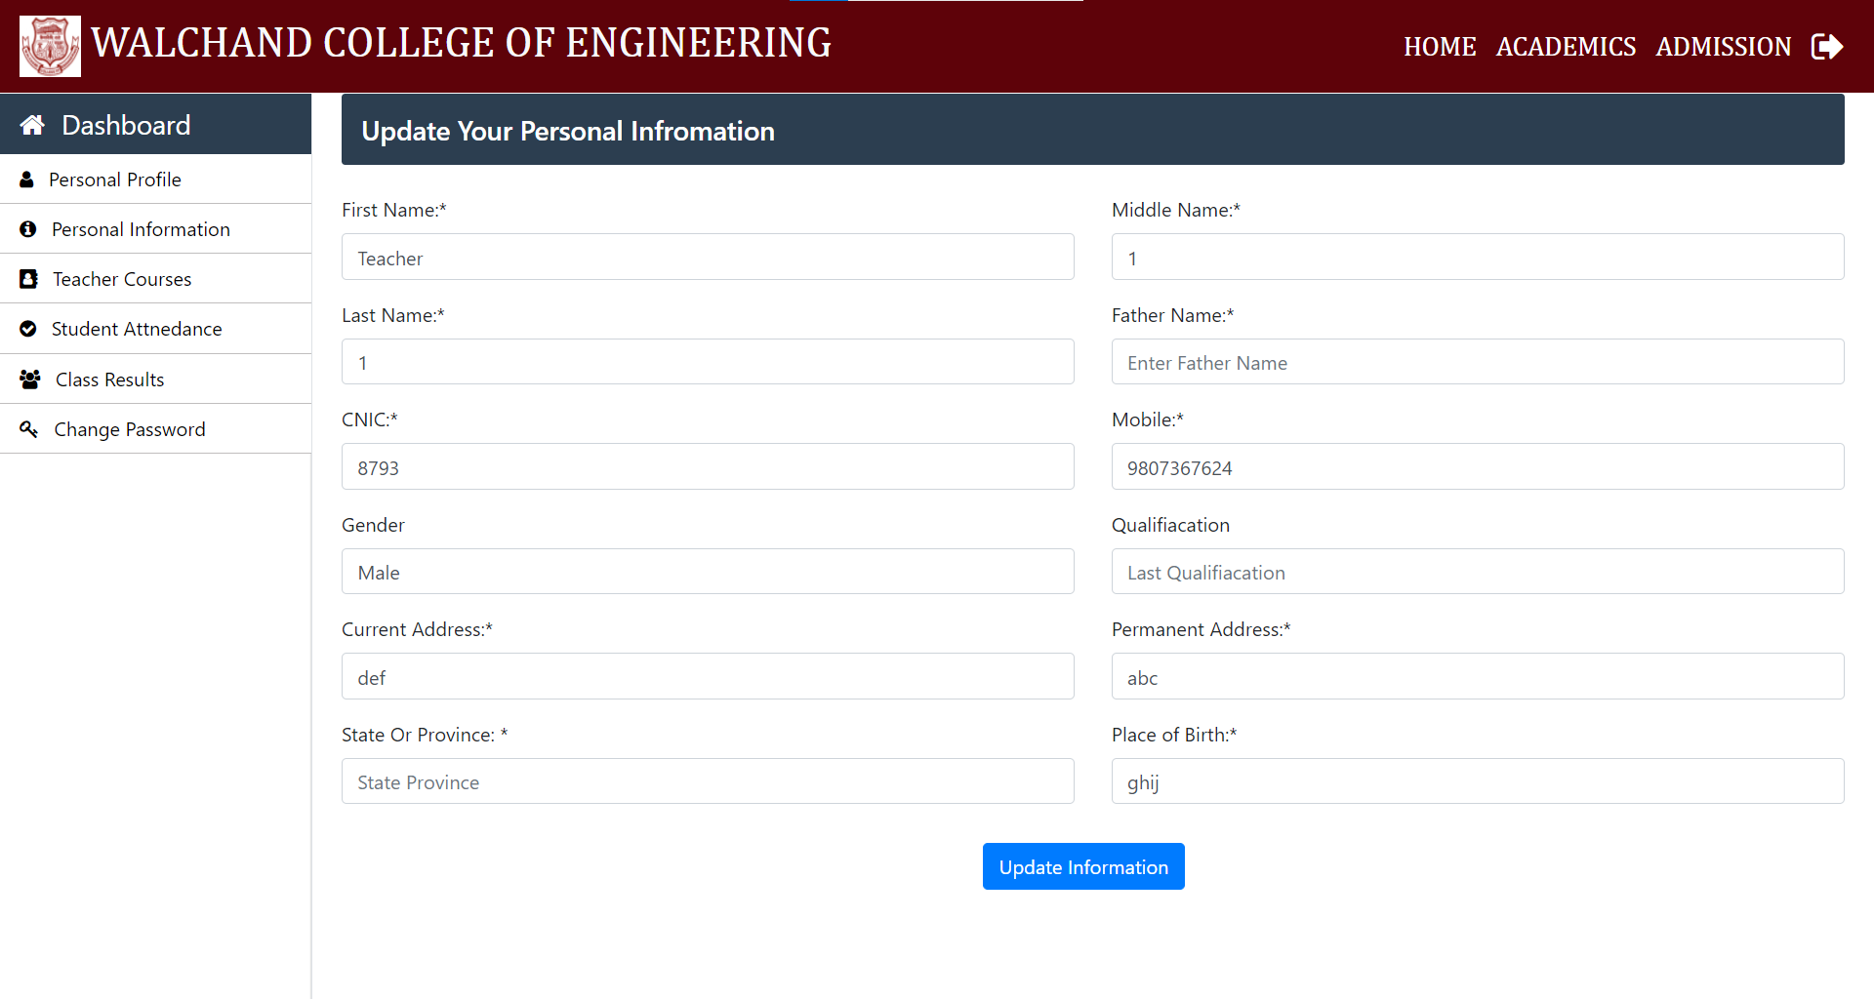

Teacher: Class Result

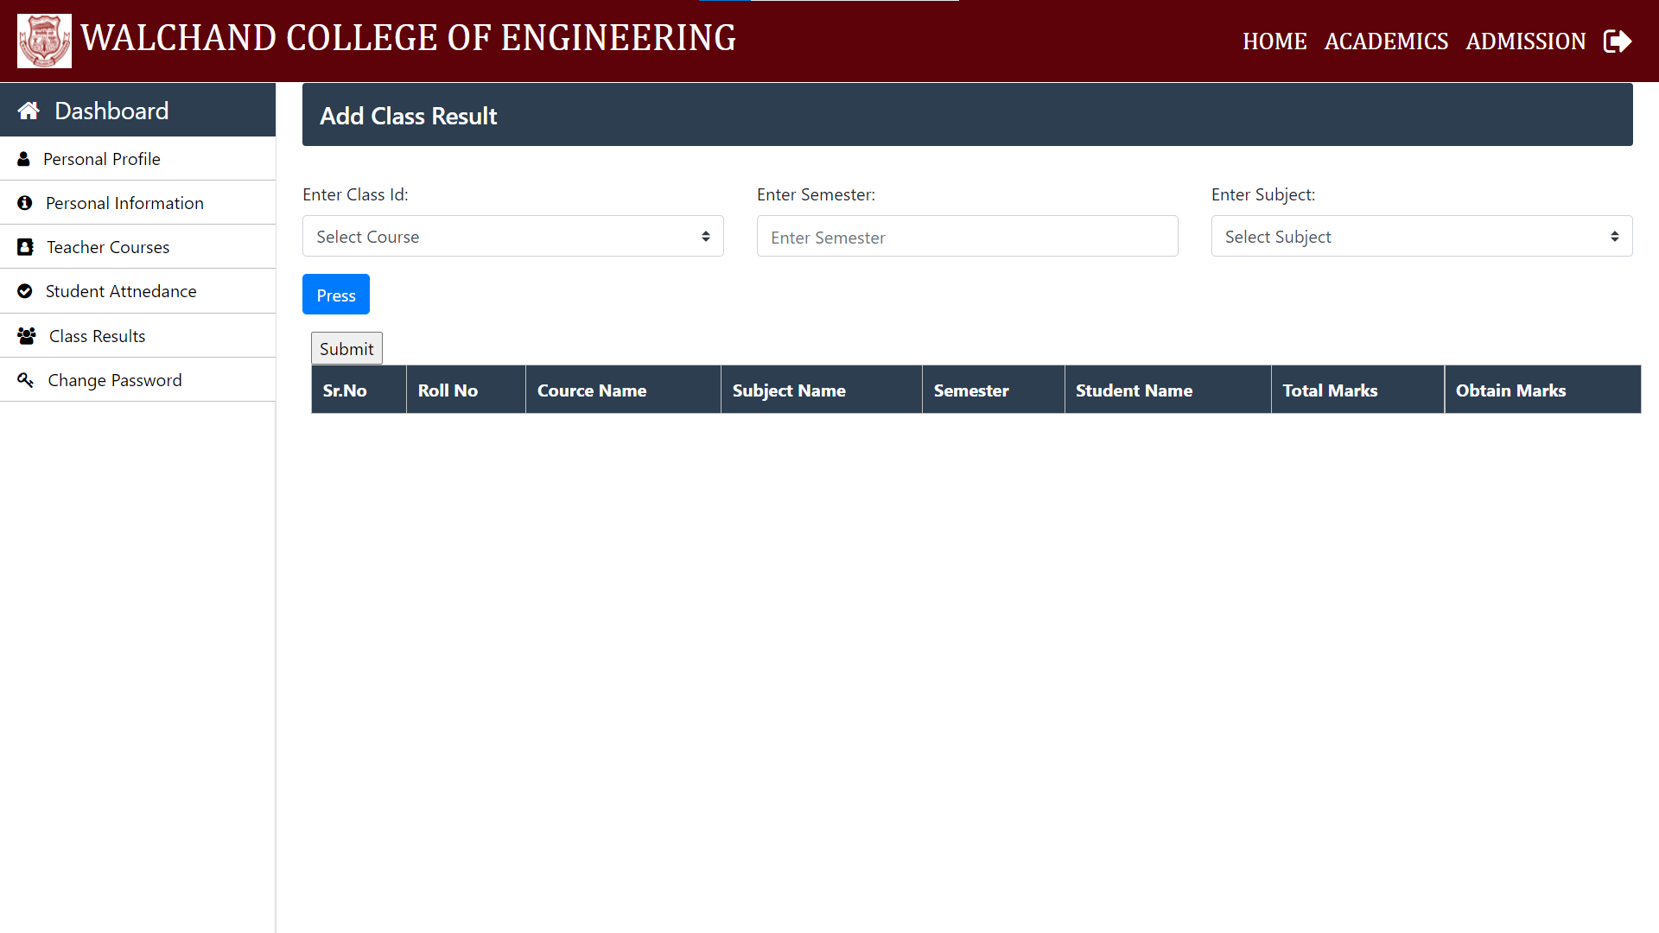

Student Dashboard Page

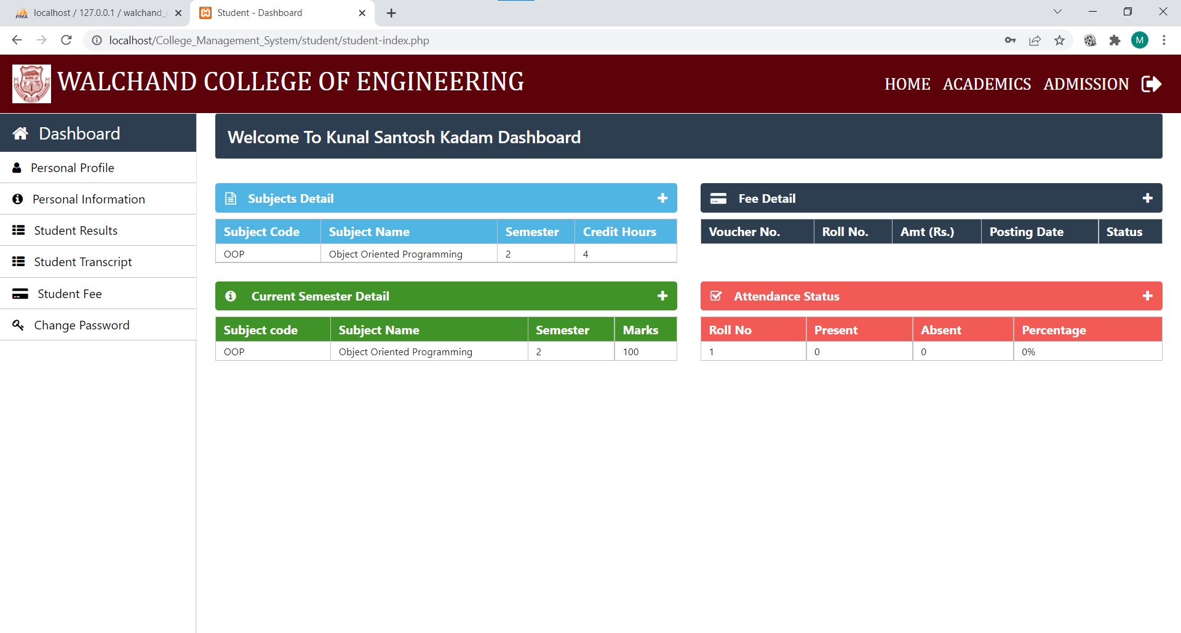

Student Info Page

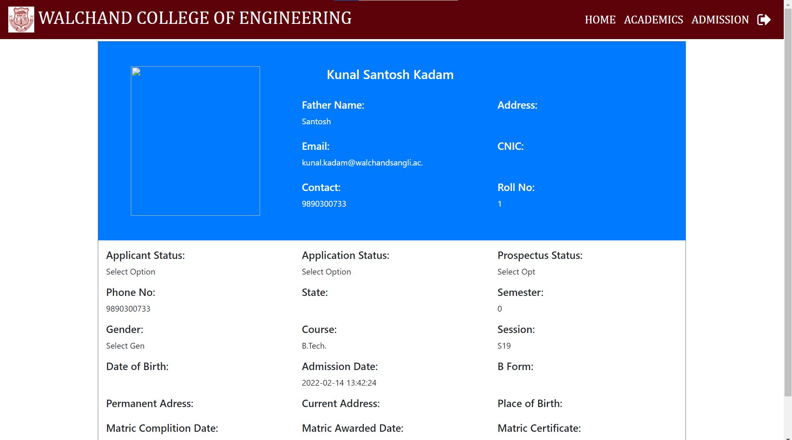

Student Information Update Page

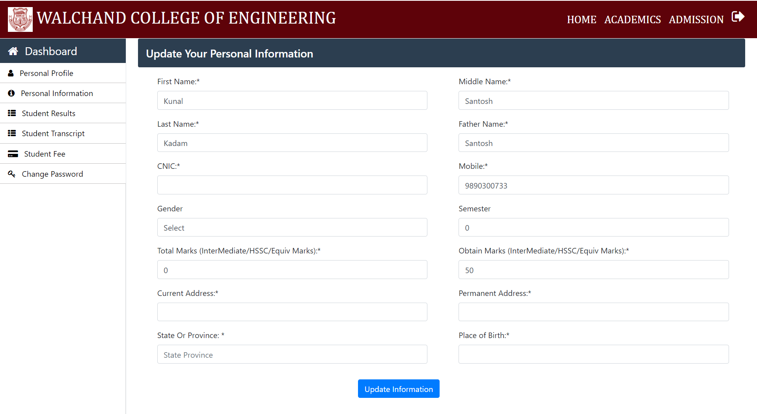

Student Result Page

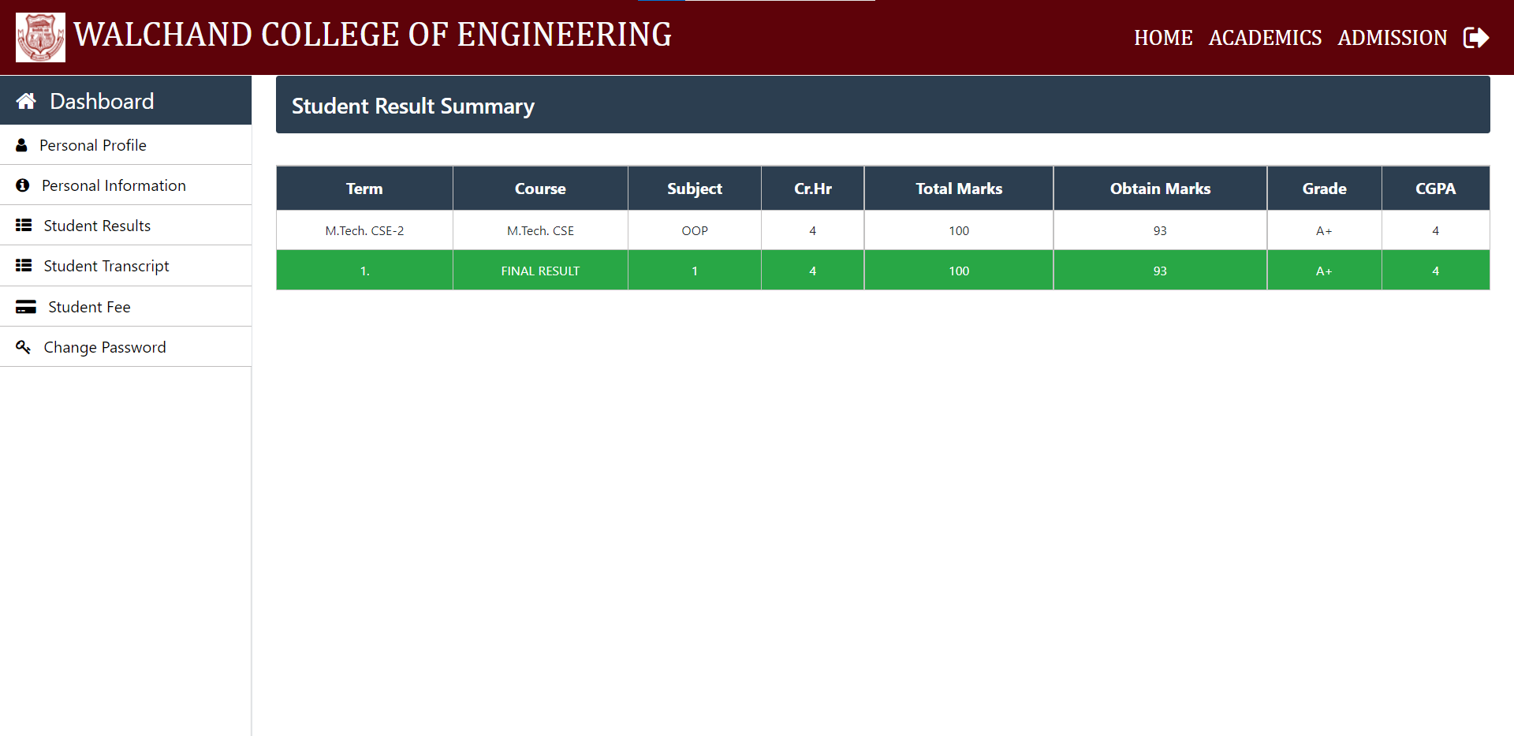

Student Grade Page

